DEPLOYMENT INSTRUCTIONS

Read Carefully

----------------------------------------------------------------------------------------------
FOLD

1. Remove plastic wrap  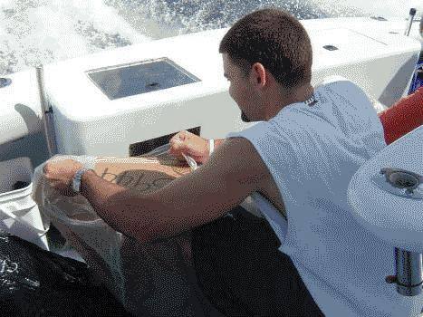 | 2. DO NOT REMOVE paper tape, cardboard, or anything BUT plastic.  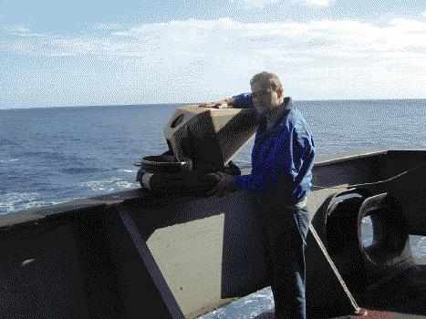
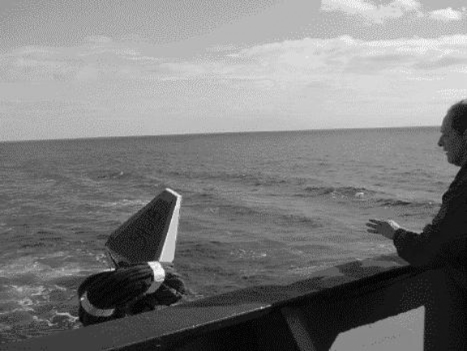3. Throw buoy in water. | 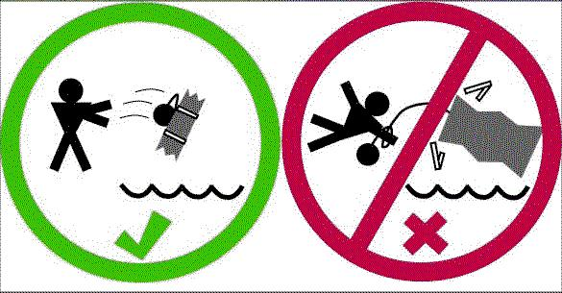

DEPLOYMENT INSTRUCTIONS

SVP AND SVP-BAROMETER DRIFTERS

- Remove the buoys from the shipping container. REMOVE ONLY the plastic shrink-wrap.
- DO NOT REMOVE paper tape securing the drogue and tether. DO NOT REMOVE cardboard surrounding the float.

DANGER: DO NOT REMOVE the paper tape securing the tether and drogue. If you do, the drogue and/or tether can unfurl during deployment and cause injury!!!

3) Record the five digit ID number of the drifter. This number can be found on the shipping container, the plastic shrink-wrap or the protective cardboard box. It is also inscribed on the surface float.

4) If testing the buoy is desired prior to deployment, the magnet can be removed from the buoy by separating it from the float through a hole in the box surrounding the float. This action will start the ARGOS transmitter for testing. Re-attaching the magnet in the same position will turn off the transmitter and reset the program starting point. The transmitter will restart on its original program when the magnet is again removed.

5) Throw the buoy from the stern, lowest possible deck (preferably less than 10 meters including heave), into the sea. The ship may be traveling between 2 - 25 knots. The tether and drogue are secured with paper tape that will dissolve in the water.

6) Record the date, time (GMT) and location of deployment as well as the five digit ID, and send this information to the Global Drifter Program.
Thank you very much for your help!
CONTACT PERSON:

Shaun Dolk, Global Drifter Program
NOAA/AOML/PhOD
4301 Rickenbacker Cswy
Miami, FL 33149, USA
Tel: 305-361-4546 Fax: 305-361-4366
E-mail: Shaun.Dolk@noaa.gov

Web site: http://www.aoml.noaa.gov/phod/dac/dep_form.html.
**************************************************************************
Sample log sheet

ID Date Time (GMT) Latitude Longitude
xxxxx mm/dd/yy hh:mm DD mm.mm N/S DDD mm.mm E/W

_______ ____/____/____ ____:____ ____ _______ __ ____ ________ __

_______ ____/____/____ ____:____ ____ _______ __ ____ ________ __

_______ ____/____/____ ____:____ ____ _______ __ ____ ________ __

_______ ____/____/____ ____:____ ____ _______ __ ____ ________ __

